Use Case 1: Adding money

Step 1: Write in the item, data, and amount

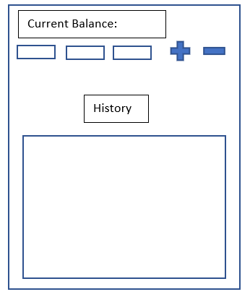

Paycheck

3/6

20

Step 2: Press the plus sign to add it to your history and increase your current balance

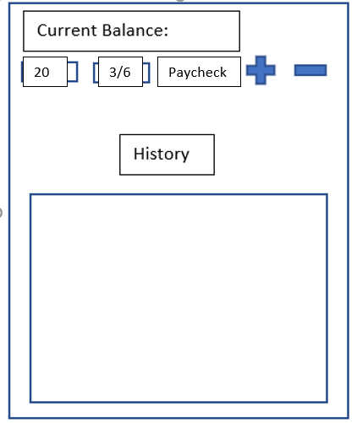

Step 3: Watch the transaction be added onto your history and your current balance increase



Added $20 on 3/6 because paycheck

$20

Use Case 2: Add a spending

Step 1: Write in the item, data, and amount



Dinner

3/8

10

$20

Step 2: Press the minus sign to add it to your history and decrease your current balance

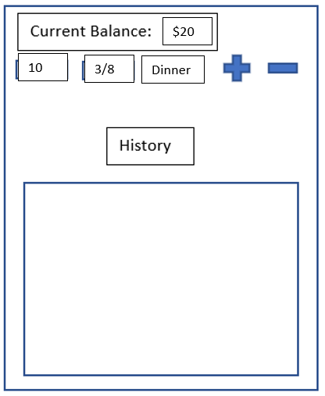

Step 3: Watch the transaction be added onto your history and your current balance decrease



Added $20 on 3/6 because paycheck

Spent $10 on 3/8 because dinner

$10